AI-Powered CI/CD Predictor | Module I (Metadata Model)
Executive Validation Report
Artifact ID: run_20260926_013515 | Model: Gradient-Boosted Trees (LightGBM) with probability calibration | Inputs: 38 metadata signals
1. Executive Summary & Global Performance
Dataset - how the builds were split for training and testing (70 / 15 / 15)
Split | Total Builds | Failed | Passed | Failure Rate
Train | 643,883 | 161,631 | 482,252 | 25.10%
Validation | 137,975 | 34,635 | 103,340 | 25.10%
Test | 137,975 | 34,635 | 103,340 | 25.10%
Total | 919,833 | 230,901 | 688,932 | 25.10%
919,833 unique build events after removing duplicate matrix jobs. About 1 in 4 builds (25.10%) truly fail.
Headline results at the Standard Gate (0.50), measured on builds the model never saw
Value | Metric | What it means
0.8579 | Ranking Ability (ROC-AUC) | 0.5 = coin flip, 1.0 = perfect
0.7449 | PR-AUC | ranks failures under imbalance
84.15% | Overall Accuracy | 116,104 of 137,975 correct
0.52% | Calibration Error (ECE) | 80% risk = about 80% fail
51.19% | Bug Catch Rate (Recall) | real failures caught (0.50)
78.12% | Alarm Accuracy (Precision) | warnings that were real bugs
61.85% | F1-Score | balance of recall & precision
4.9 ms | Prediction Speed | single vector, under 5 ms (P95)
What this model does
Module I looks only at the metadata around a code change (repository size and age, commit history, test coverage, who committed, and how the change was submitted) and predicts how likely the build is to fail before any tests or compilation run. Each commit is scored in under 5 milliseconds, so the check adds no meaningful wait to the pipeline.
On 137,975 real builds it had never seen, the model correctly ranks a failing build above a passing one about 86 times out of 100 (0.8579 ranking ability, where 0.50 is a coin flip). Its risk scores are trustworthy as real probabilities: when it says a build is 80% likely to fail, about 80% of those builds actually do (calibration error of just 0.52%).
Teams choose how strict to be. A low cutoff (0.25) catches 73% of real failures for broad early screening; the Strict Pre-Merge Block (0.65) stops only the riskiest commits, and 88% of what it blocks would genuinely have failed. This catches bugs earlier while wasting as little developer time as possible on false alarms.

2. What Drives the Prediction, and Does It Hold Up Across Groups?
Chart 1: What the model pays attention to (top 15 signals)
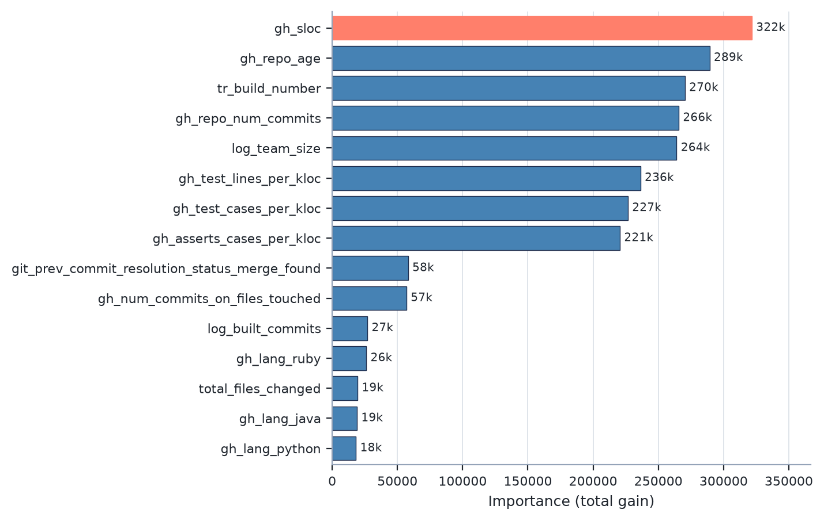
The strongest signals are repository scale (lines of code), maturity (age and commit history), team size, and test-suite density (test lines, cases, and asserts per 1,000 lines) - all available before a build runs, with zero test execution.
Chart 2: Does it work equally well across groups?
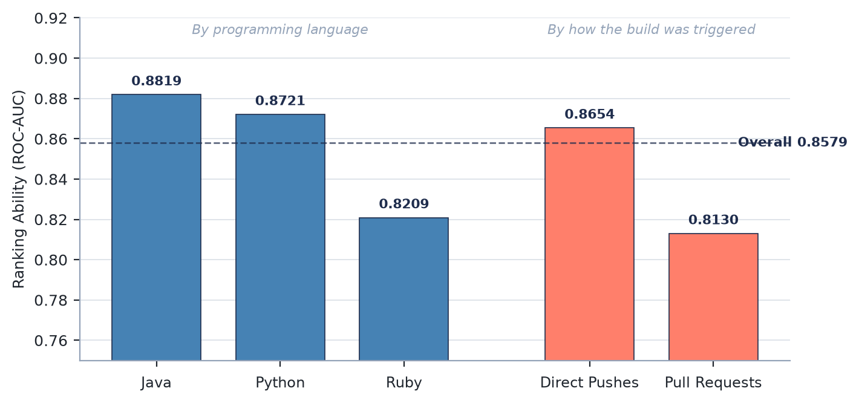
Every subgroup scores within 0.045 of the overall model and no group falls below 0.82. The widest gaps (Ruby and Pull Requests) reflect fewer training examples, not unfair treatment.

Feature Verification & Leakage Audit
VERIFIED PRE-BUILD Every top signal (gh_sloc, gh_repo_age, tr_build_number, gh_repo_num_commits, log_team_size, and test-suite density) is static or historical metadata known at git commit time - computed with zero test execution and no runtime information.
LEAKAGE EXCLUDED Post-build fields (tr_duration and all runner-outcome columns) were audited and strictly excluded from the 38-feature vector, so no outcome of the build can leak into its own prediction.

3. How Trustworthy Are the Scores, and Where Should Teams Draw the Line?
Calibration: do the risk scores match reality?
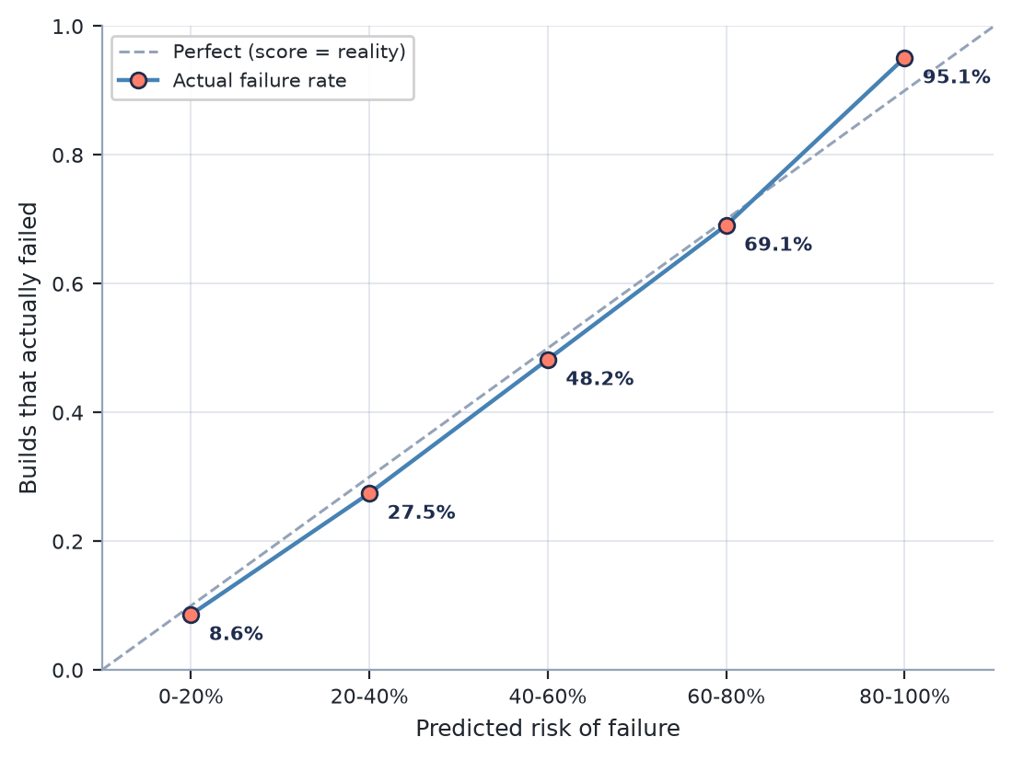
Calibration error (ECE) = 0.52% - 78% lower than the uncalibrated model.
Standard Gate (0.50) confusion matrix on the held-out test set
 | Actual PASS (103,340) | Actual FAIL (34,635)
Predicted PASS | TN 98,373 (71.30%) | FN 16,904 (12.25%)
Predicted FAIL | FP 4,967 (3.60%) | TP 17,731 (12.85%)
Threshold 0.50 | Accuracy 84.15% | Precision 78.12% | Recall 51.19%
Decision Matrix: where should the team draw the line?
Policy | Threshold | Recall | Precision | FPR | Use Case
Low Risk | 0.25 | 73.47% | 56.55% | 18.92% | Broad early screening
Balanced Tier | 0.42 | 57.67% | 72.23% | 7.43% | Balanced catch vs. accuracy
Standard Gate | 0.50 | 51.19% | 78.12% | 4.81% | Default build gate
High Risk Tier | 0.55 | 47.55% | 81.31% | 3.66% | Accuracy-leaning gate
Strict Pre-Merge Block | 0.65 | 40.31% | 87.51% | 1.93% | Blocks riskiest commits
Operational Trade-Off: Recall vs. False Alarms
A missed failure (false negative) breaks the shared trunk and stalls the whole team; a false alarm only adds a little friction - so accuracy alone is not enough. The tiered gates let teams trade an 18.92% false-alarm rate for a 73.47% catch rate when fast-tracking PRs, or run at just 1.93% false alarms for strict pre-merge blocking.
Robustness Stress Check
PASS all 4 malformed-input tests handled cleanly.
Extreme values, all-zeros, negative placeholders, and nonsense types each returned valid probabilities in [0, 1] with zero NaN or infinity results and no crashes - the scoring path stays stable on bad input.

4. Explainability: How Individual Features Shift Failure Risk
TreeSHAP attribution on a representative test sample (N=5,000) from baseline risk (25.1%).
Global Signal Attribution (Top 10 Drivers)
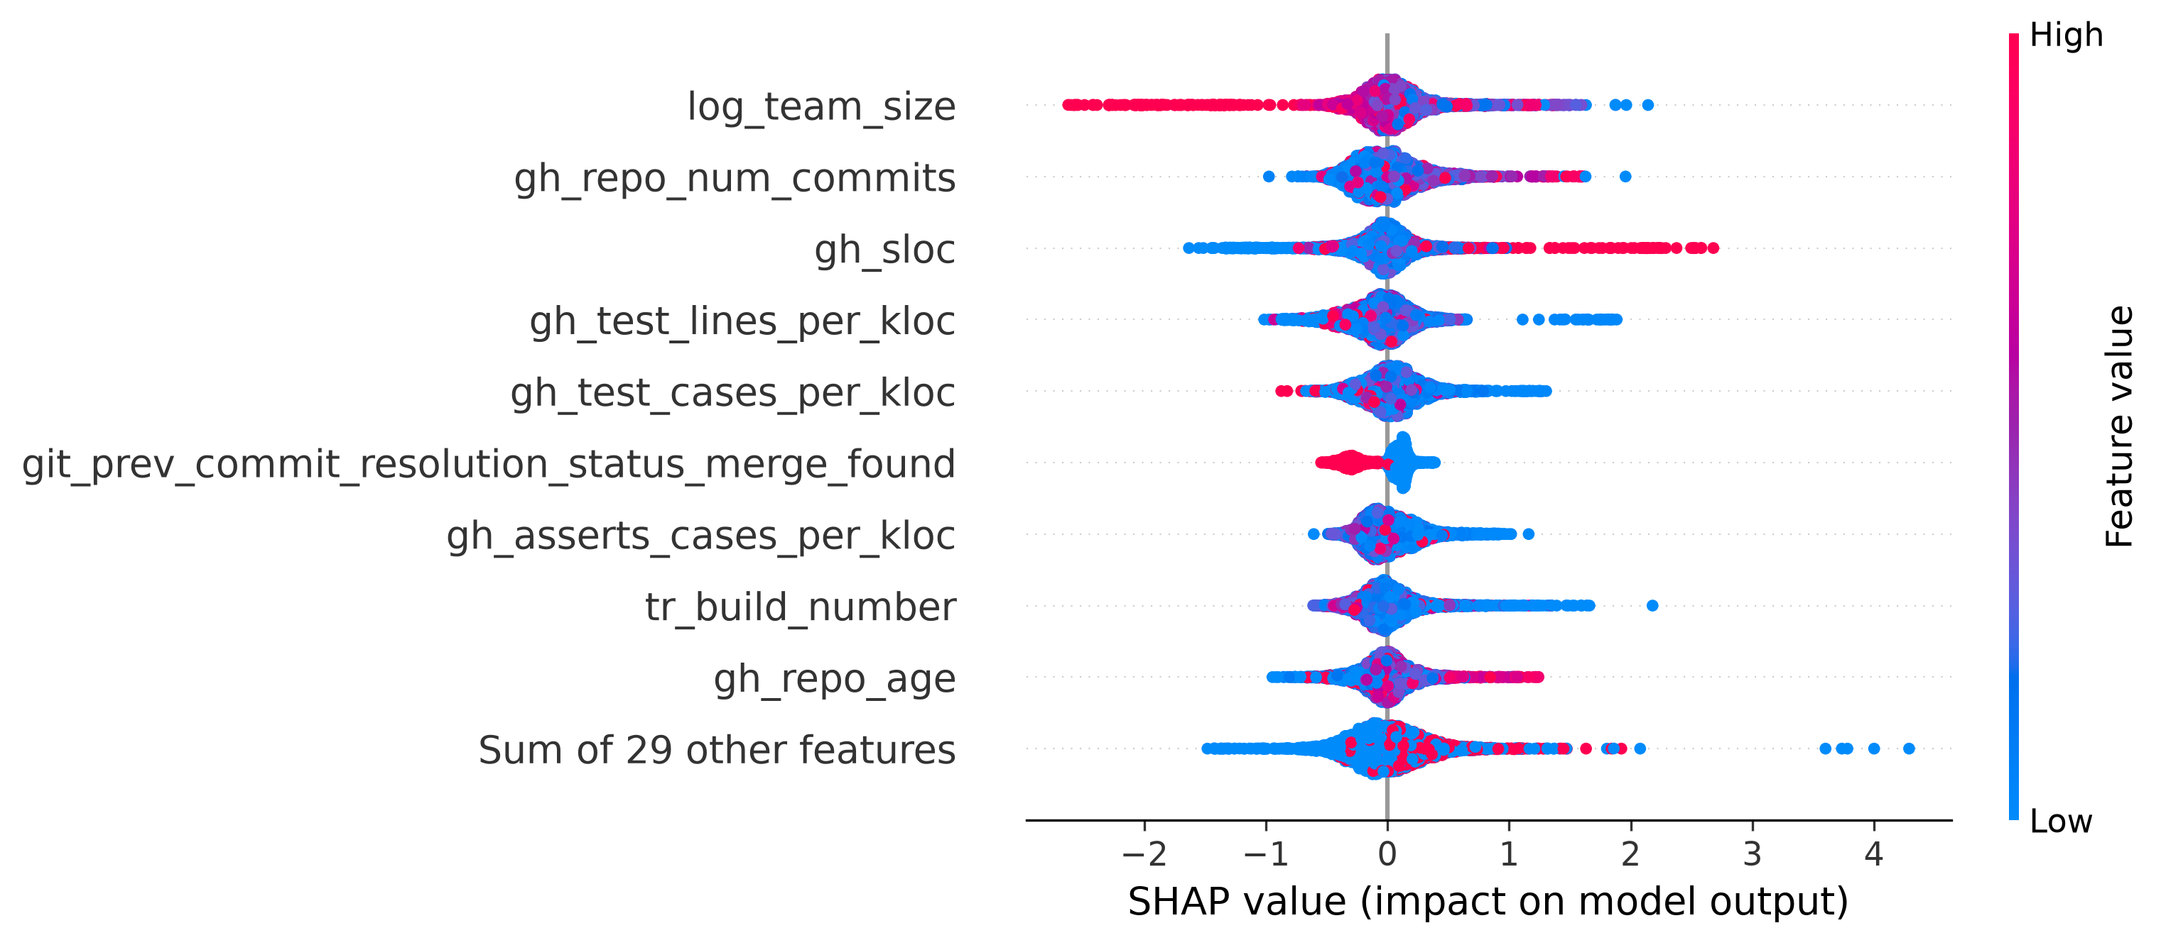
Global view across all 5,000 held-out test builds. Each dot is one build; dot COLOR encodes the feature's magnitude (red = high value, blue = low value). Horizontal POSITION is that feature's SHAP impact on failure risk - dots to the RIGHT push the commit toward failure, dots to the LEFT pull it toward a safe pass. Features are ordered top-to-bottom by mean absolute impact, so the strongest global drivers (team size, repository scale, and test-suite density) sit at the top.

5. Explainability: A Single Commit, Decomposed
Local TreeSHAP attribution for one canary-blocked commit, and how it feeds Module III.
Local Attribution: Canary-Blocked Commit (predicted risk > 0.65)
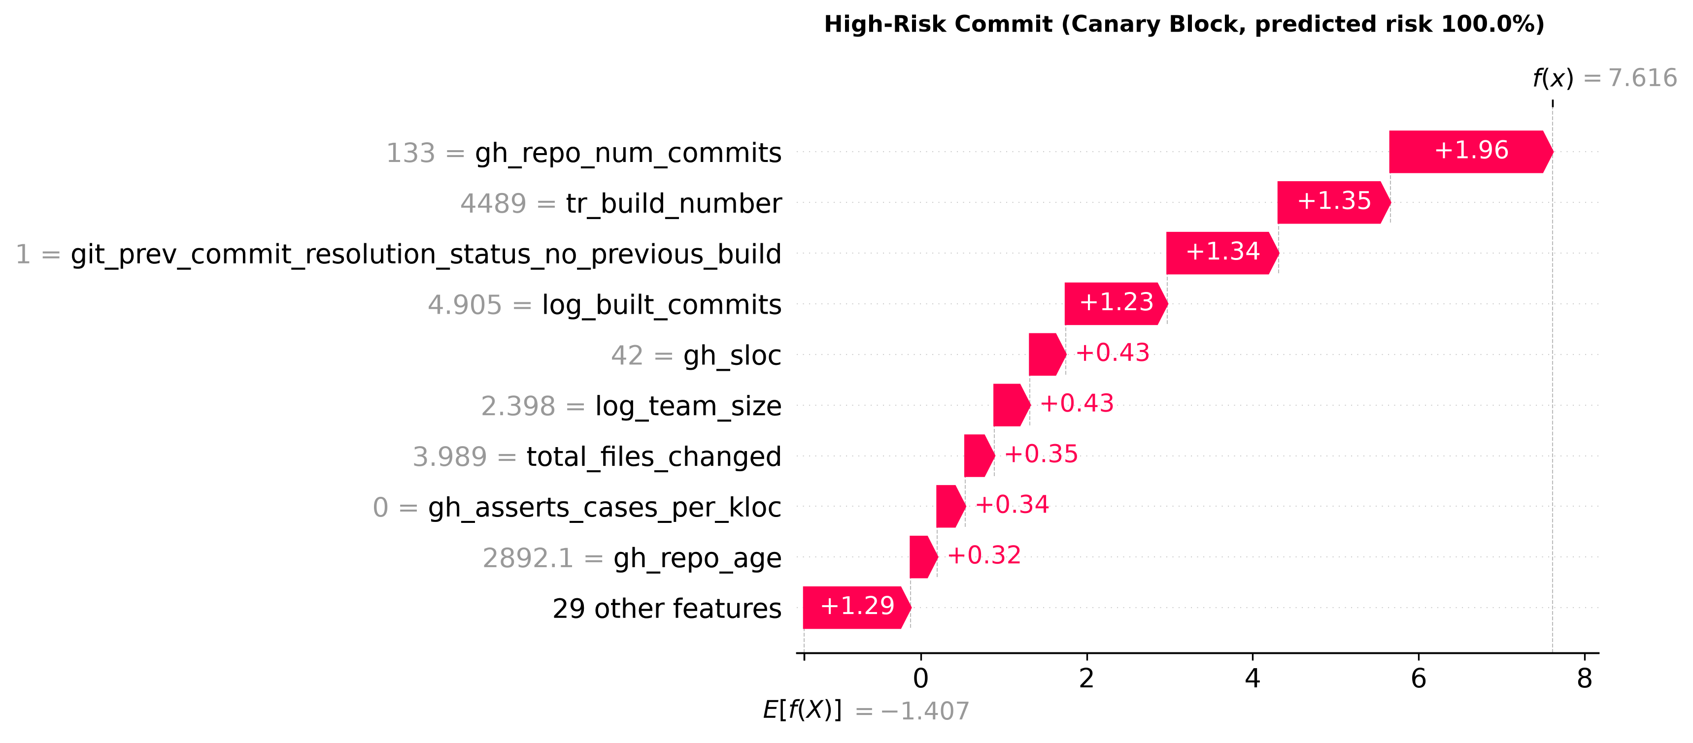
Step-by-step risk accumulation for one individual commit that the Strict Pre-Merge Block (0.65) would stop. Bars start at the baseline E[f(x)] - the average risk across the sample - and each feature adds (red, pushes toward failure) or subtracts (blue, pushes toward pass) until reaching this commit's final predicted risk. The values are exact SHAP contributions in log-odds, so the bars sum precisely to the prediction.
Integration with Module III (Assisted Root Cause Analysis)
Pre-Build Risk Context: These per-commit SHAP attributions provide the pre-build explanation for Module III. Before any test or build executes, the system identifies which repository signals (team size, repository scale, test density, historical churn) drove the initial failure risk.
Joint Diagnostic Synthesis: When a pipeline fails at runtime, Module III pairs these pre-build SHAP risk drivers with mid-build terminal log tokens. The metadata explains WHY the build was vulnerable, and the logs pinpoint WHERE it broke - enabling rapid automated remediation.

